

DATA STRUCUTRES AND ALGORITHMS
23CSE203
LAB MANUAL
Submitted by

Name | PALAPARTHI KUSUMA
Roll No | AV.SC.U4CSE25045
Year/Sem/Section | 2nd year/Sem-3/CSE-A
Credits | 05

Submitted to

Name | Dr. RAJ KUMAR BATCHU
Department | School of Computing
Designation | Asst. Professor (SI Grade)

S.NO | TITLE | PAGE NO | REMARKS
1. | WEEK 1: 1a. Recursive countdown from n to Launch.  1b. Recursive calculation of compound growth factor.  1c. Recursive search for employee ID in list.  1d. Recursive factorial calculation for parcel arrangements.  1e. Recursive Fibonacci series generation. | 3 - 11
2. | WEEK 2: 2a. Python program to perform linear search on the given input.  2b. Python program to perform binary search on the given input.  2c. Verify by taking sorted array and unsorted array as an input. | 11 - 16
3. | WEEK 3: 3a. Python program to perform bubble sort on the given input.  3b. Python program to perform insertion sort on the given input.  3c. Python program to perform selection sort on the given input.  3d. Python program to perform merge sort on the given input.  3e. Python program to perform quick sort on the given input. | 15 - 22
4. | WEEK 4: 4. Python program to implement a menu-driven Singly Linked List (SLL) with the following operations:  - Create a list  - Insert at beginning/end/specific position  - Delete by value/first/last node  - Count and display nodes  - Exit | 22 - 27

WEEK – 1
1a. AIM: A rocket launch system displays a countdown before launch. Instead of using a loop, implement the countdown using recursive. Write a recursive python program to display a countdown from n to 1, followed by “Launch”.
PROGRAM:
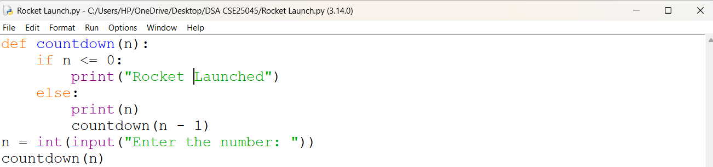
OUTPUT:
Positive Case;
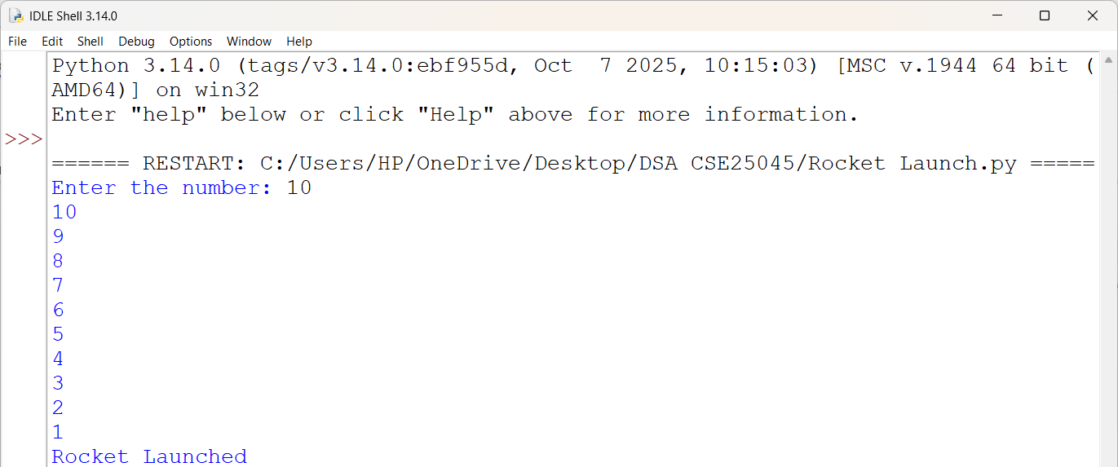
Negative Case;
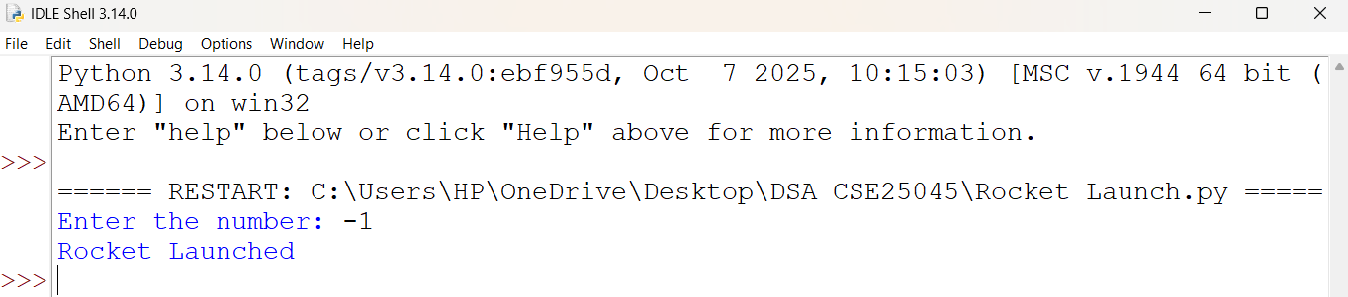

EXPLANATION:
- It takes a number as input from the user and stores it in n.
- It creates a recursive function named countdown() that prints the countdown.
- If n is greater than 0, it prints the current value and calls countdown(n - 1) to continue the countdown.
- When n becomes 0 or less, it prints "Rocket Launched" and stops the recursion.
- Finally, it starts the recursive countdown by calling countdown(n).

ERROR TABLE:
S.NO | Error Obtained | Rectification
1. | Syntax Error  Forgot to give the ":" after the if, else, or function definition. | It was rectified by adding the missing ":".
2. | Value Error  Entered a non-integer value instead of an integer. | It was rectified by entering only integer values as input.

1b. AIM: Banks calculate the growth of an investment using compound interest. The formula requires calculating powers, which can be implemented recursively. Write a recursive program to calculate P^{n}(power), Where p = principal growth factor, n = number of years.
PROGRAM:
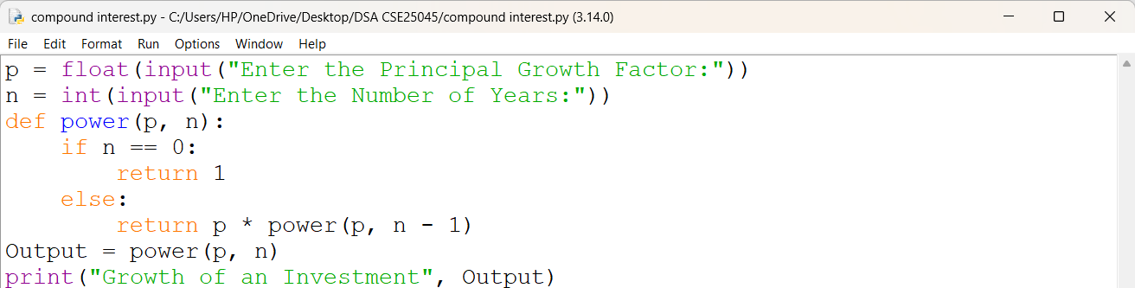

OUTPUT:
Positive Case;
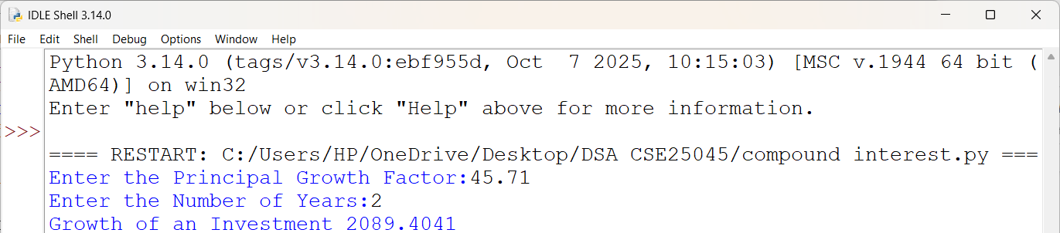
Negative Case;
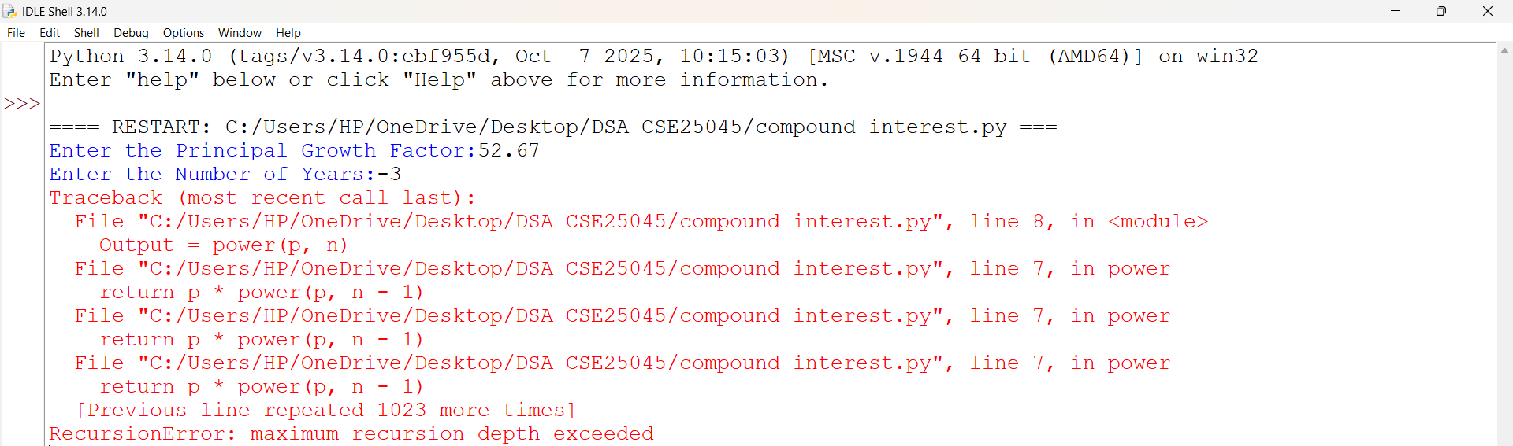

EXPLANATION:
- The program accepts the growth factor p and the number of years n as input and calls the recursive function power(p, n).
- The function checks the base case if n == 0; if true, it returns 1, since any number raised to the power 0 is 1.
- If n > 0, the function recursively computes the result by returning p * power(p, n - 1) until the base case is reached.
- If n < 0, the recursive calls continue indefinitely because the base case is never satisfied, resulting in a Recursion Error.
- Finally, for valid non-negative inputs, the program displays the value of pⁿ, representing the growth factor raised to the given number of years.

ERROR TABLE:
S.NO | Error Obtained | Rectification
1. | Invalid Input Error  I entered a floating-point value instead of an integer for the number of years. | It was rectified by entering an integer value.
2. | Large Input Error  I entered a very large value for the number of years. | It was rectified by entering a smaller input value within Python's recursion limit.

1c. AIM: An HR department stores employee IDs in a list. Develop a recursive program to search for a given employee ID. Write a recursive function to search for an employee ID in a list.
PROGRAM:
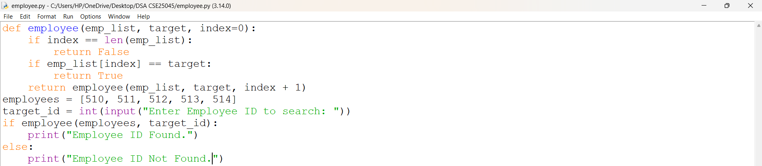
OUTPUT:
Positive Case and Negative Case;

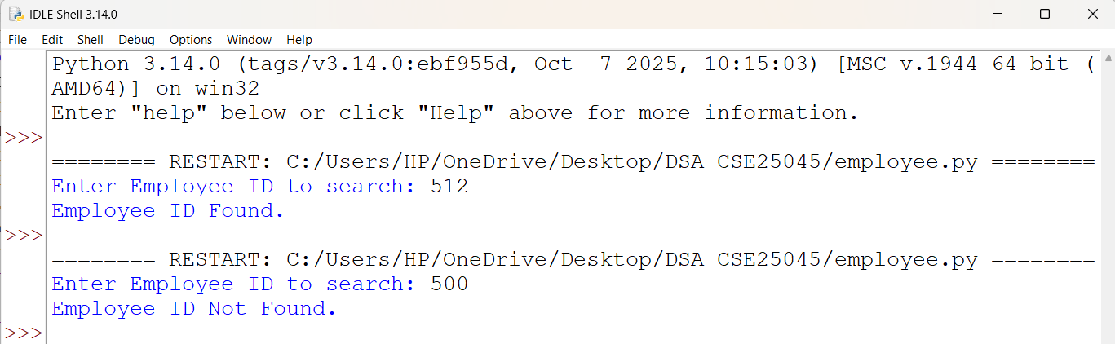

EXPLANATION:
- The program accepts the Employee ID as input and invokes the recursive function search_employee(emp_list, target, index) with the initial index set to 0.
- The function compares emp_list[index] with the target Employee ID. If they are equal, it returns True, terminating the recursion.
- If no match is found, the function recursively calls itself with index + 1 to search the next element in the list.
- The base case is reached when index == len(emp_list), indicating that all elements have been searched. The function then returns False.
- Based on the returned Boolean value, the main program displays either "Employee ID Found ." or "Employee ID Not Found.".

ERROR TABLE:
S.NO | Error Obtained | Rectification
1. | List Initialization Error  I have not entered any Employee IDs in the list. | It was rectified by adding the required Employee IDs to the list before performing the search.
2. | Index Error  I tried to access an index beyond the size of the list. | It was rectified by checking the base condition before accessing the list element.

1d. AIM: In a logistics company, the number of possible ways to arrange n different parcels is calculated using the factorial formula (n!). Develop a recursive program to calculate the factorial of a given number.
PROGRAM:
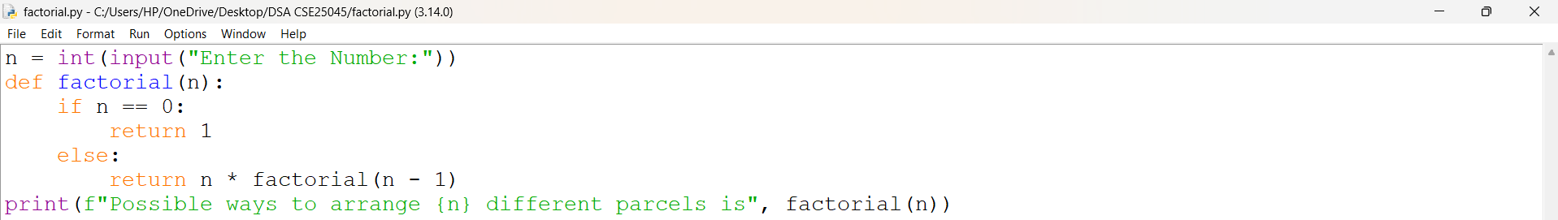
OUTPUT:
Positive Case;
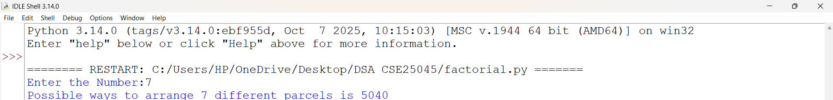
Negative Case;
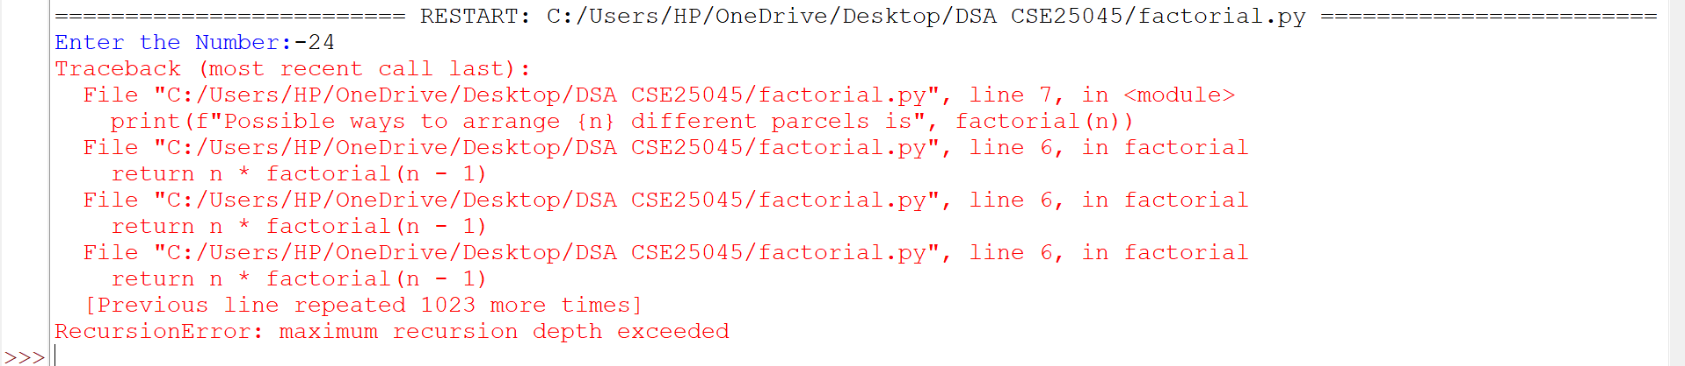
EXPLANATION:
- The program accepts an integer n as input and calls the recursive function factorial(n).
- The function checks the base case if n == 0; if true, it returns 1, since 0! = 1.
- If n > 0, the function recursively calls factorial(n - 1) and returns n * factorial(n - 1) to compute the factorial.
- The recursion continues until the base case is reached, after which the recursive calls return the final factorial value.
- Finally, the program displays the total number of possible arrangements (n!) for the given number of parcels.

ERROR TABLE:
S.NO | Error Obtained | Rectification
1. | Negative Input Error  I entered a negative integer as input. | It was rectified by entering a non-negative integer (n ≥ 0).
2. | Name Error  I called the function with an incorrect function name. | It was rectified by using the correct function name factorial().

1e. AIM: Write a recursive python program to print the first n terms of the Fibonacci Series.
PROGRAM:
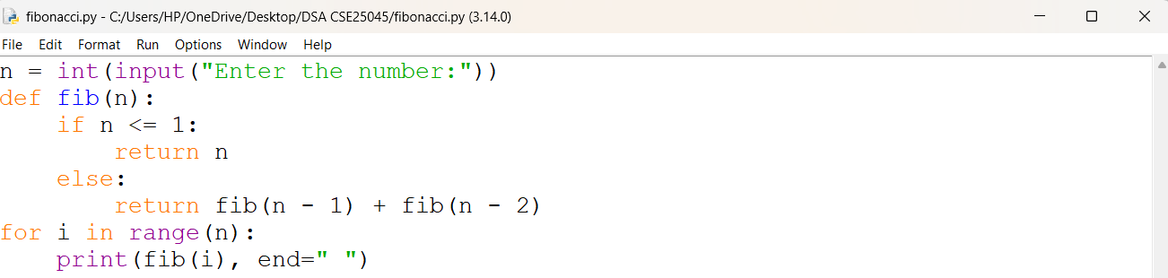

OUTPUT:
Positive Case;
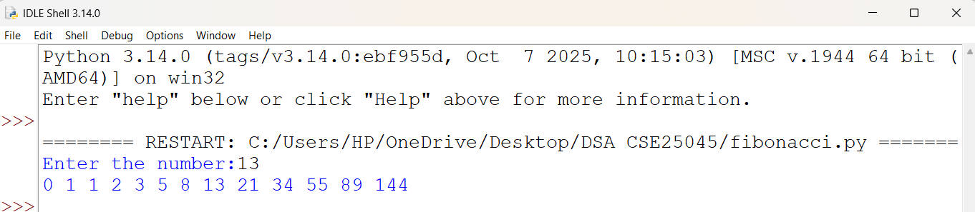

Negative Case;

EXPLANATION:
- The program accepts an integer n as input and calls the recursive function fib(n).
- The function checks the base case if n <= 1; if true, it returns n, representing the first two Fibonacci numbers (0 and 1).
- If n > 1, the function recursively computes the Fibonacci number by returning fib(n - 1) + fib(n - 2).
- The recursion continues until the base case is reached, after which the recursive calls return and calculate the required Fibonacci number.
- Finally, the program displays the Fibonacci number corresponding to the given position n.

ERROR TABLE:
S.NO | Error Obtained | Rectification
1. | Negative Input Error  I entered a negative integer as input. | It was rectified by entering a non-negative integer (n ≥ 0).
2. | Large Input Error  I entered a very large number. | It was rectified by entering a smaller input value.

WEEK – 2
2a. AIM: Write a python program to perform linear search on the given input.
PROGRAM:
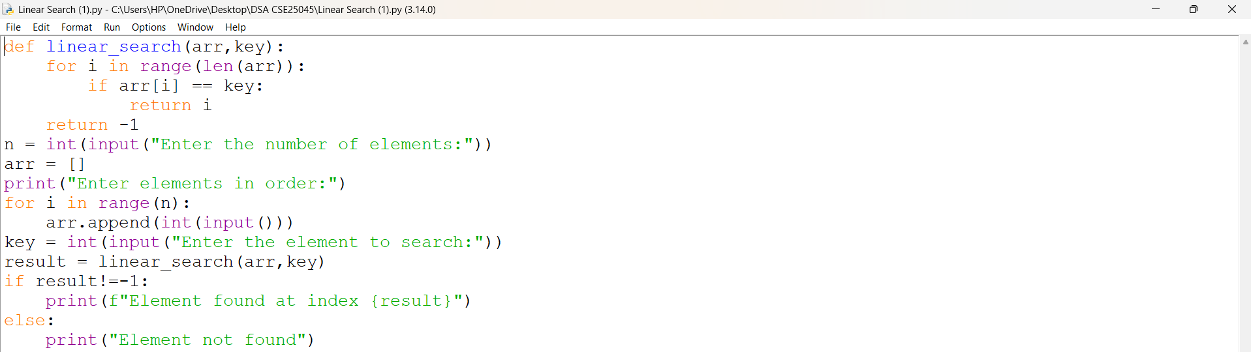
OUTPUT:
Positive Case;
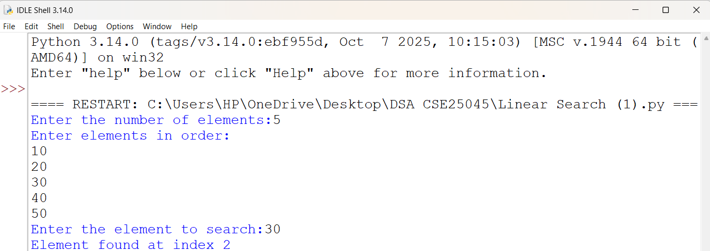

Negative Case;
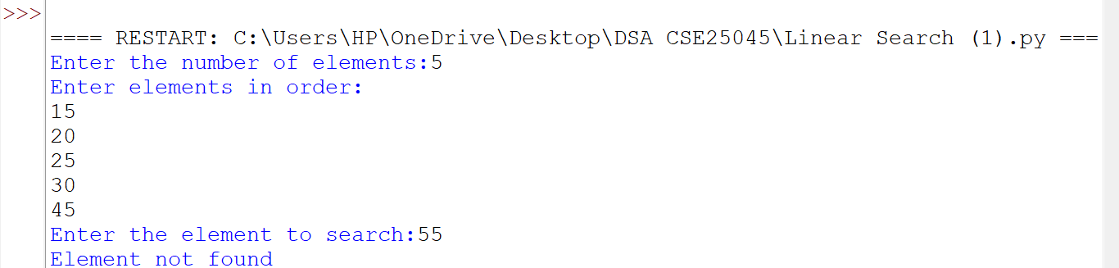
EXPLANATION:
- The program implements Linear Search to find a specific element in an array.
- It first asks the user to enter the number of elements and stores them in a list.
- The linear_search() function checks each element of the array one by one.
- If the result is not -1, it displays "Element found at index".
- If the result is -1, it displays "Element not found".
- Thus, the program demonstrates both successful (positive) and unsuccessful (negative) linear search cases.

ERROR TABLE:
S.NO | Error Obtained | Rectification
1. | Search Element Not Found: The entered element was not present in the array. | Search Element Not Found: The entered element was not present in the array.
2. | Wrong Search Result: The program was given an incorrect search element. | Re-entered the correct element to be searched.

2b. AIM: Write a python program to perform binary search on the given input.
PROGRAM:
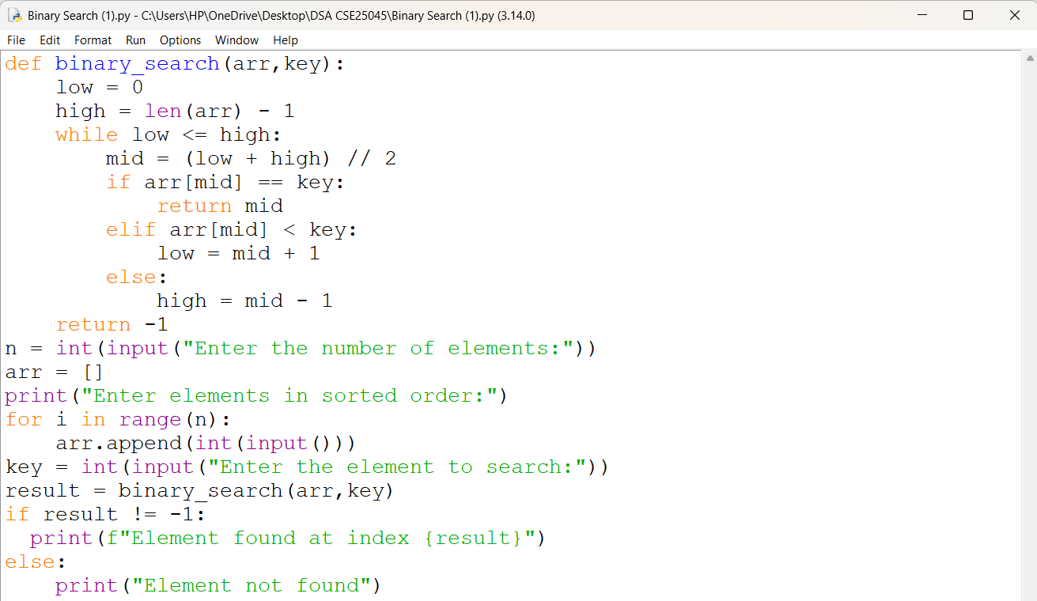
OUTPUT:
Positive Case;
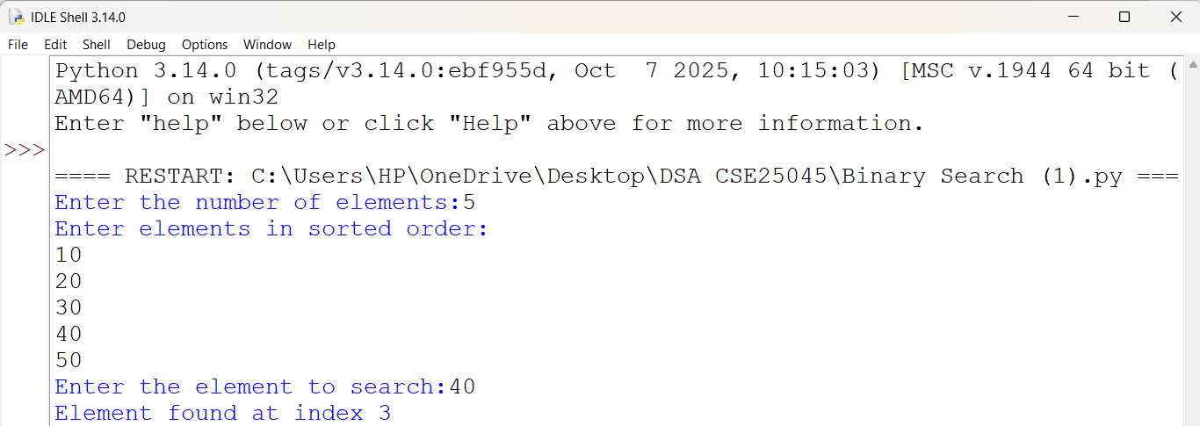
Negative Case;
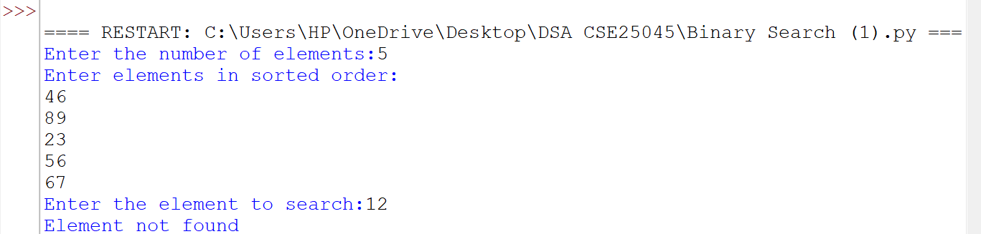

EXPLANATION:
- The program defines a binary_search() function to search for a key in a sorted arr.
- It initializes low as 0 and high as len(arr) - 1.
- The while low <= high loop calculates the mid index using (low + high) // 2.
- If arr[mid] == key, the mid index is returned.
- If arr[mid] < key, low is updated to mid + 1; otherwise, high is updated to mid - 1.
- If the key is not found, the function returns -1 and the program displays "Element not found".
ERROR TABLE:
S.NO | Error Obtained | Rectification
1. | Unsorted Array: Binary search gave an incorrect result when the elements were not in sorted order. | Entered the elements in ascending order before performing the search.
2. | Incorrect Search Range: The low and high values were not updated correctly after comparing with arr[mid]. | Updated low = mid + 1 for the right half and high = mid - 1 for the left half.

2c. AIM: Verify by taking sorted array and unsorted array as an input.
PROGRAM:
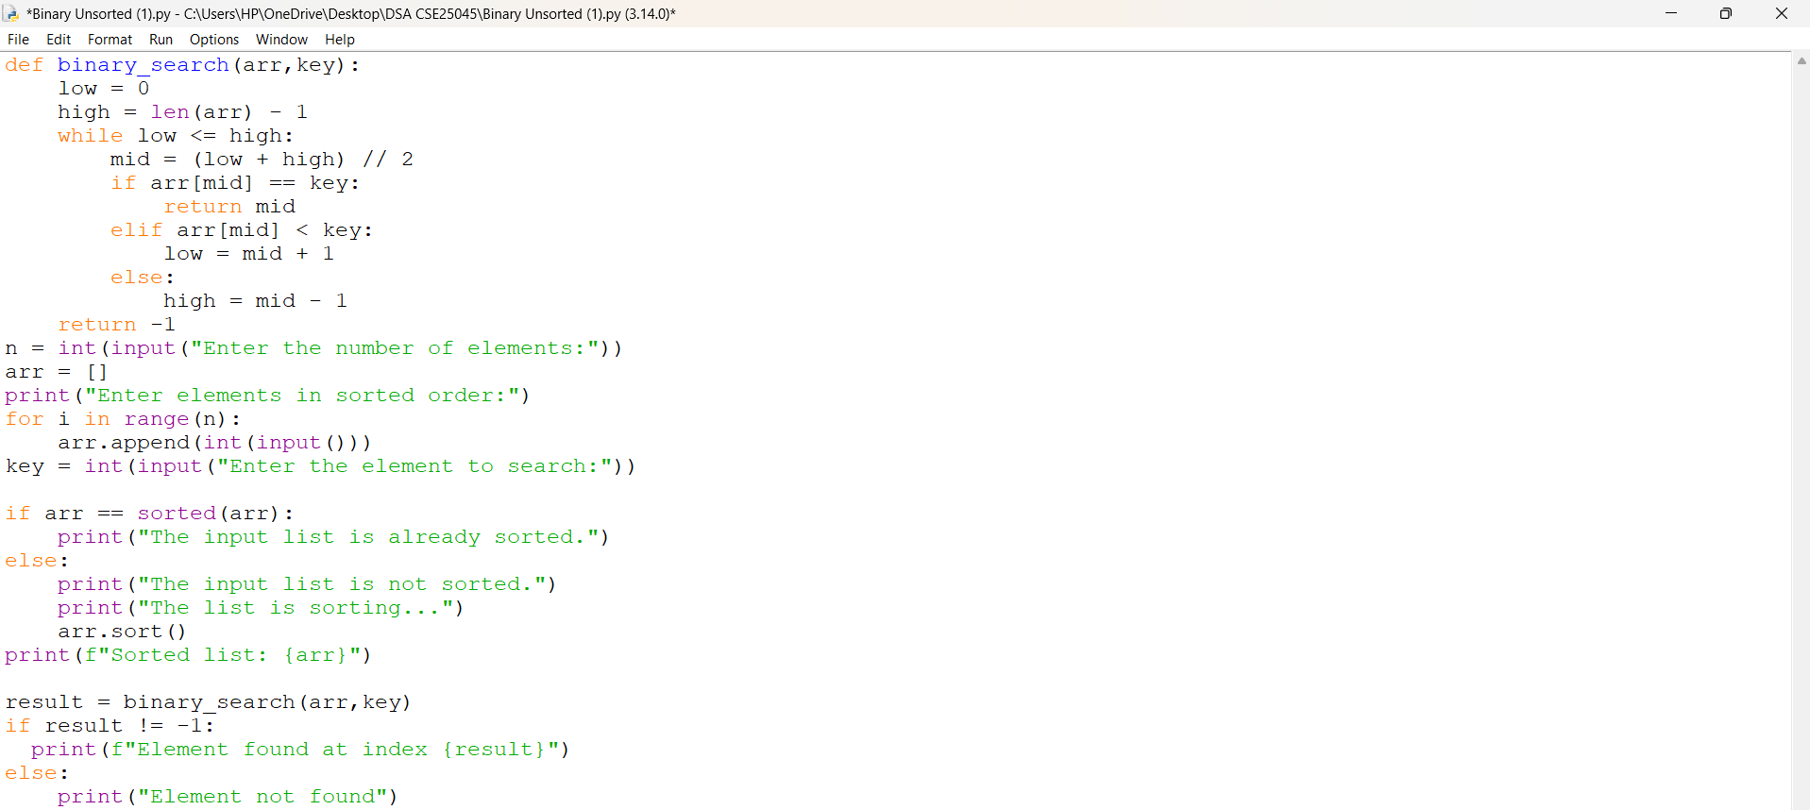
OUTPUT:
Sorted Array;
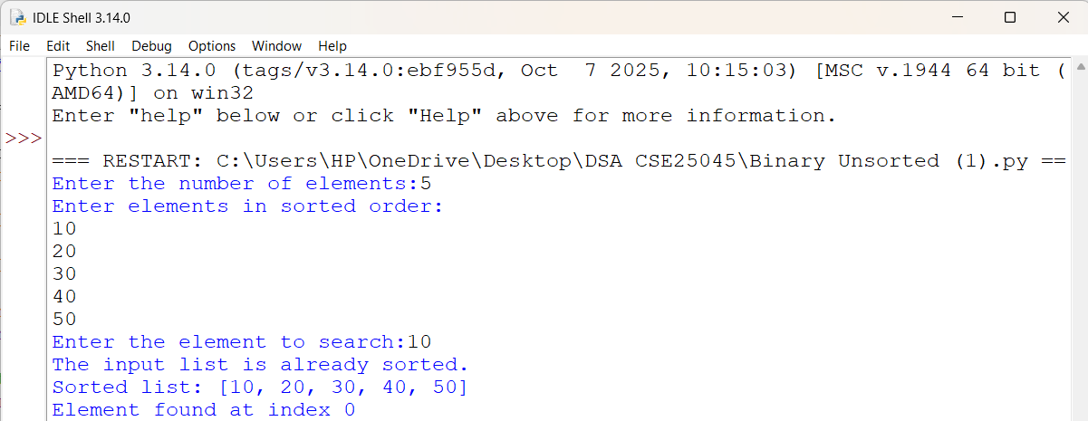
Unsorted Array;
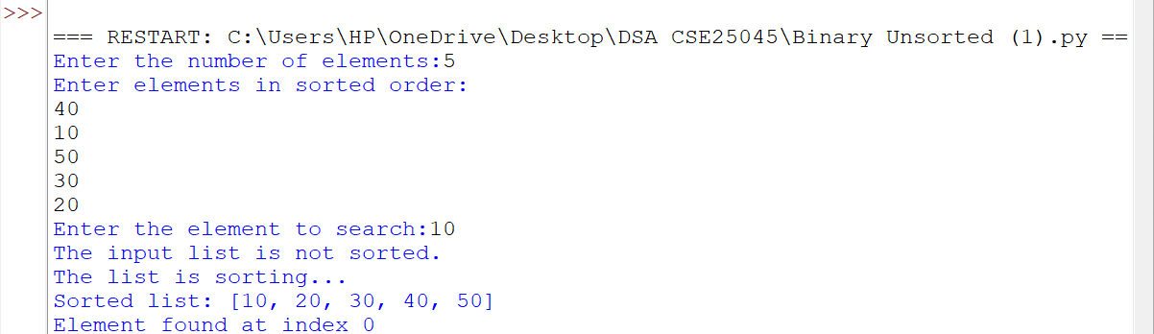
EXPLANATION:
- The program defines a binary_search() function to search for a key in an array using Binary Search.
- It initializes low and high and calculates the mid index to compare the middle element with the key.
- It checks whether arr == sorted(arr) to determine if the input list is already sorted.
- If the list is not sorted, arr.sort() sorts the elements before performing the search.
- The binary_search() function searches the sorted arr and returns the index if the key is found, otherwise it returns -1.
- Finally, the program displays whether the element is found or not found.

ERROR TABLE:
S.NO | Error Obtained | Rectification
1. | Unsorted Array: The input elements were entered in an unsorted order. | Used arr.sort() to arrange the elements in ascending order before binary search.
2. | Incorrect Sorted Order: The elements were not arranged in the required ascending order for binary search. | Checked the list using arr == sorted(arr) and sorted it when required.

WEEK – 3
3a. AIM: Write a python program to sort the elements using a bubble sort technique. Take the input elements from the user.
PROGRAM:
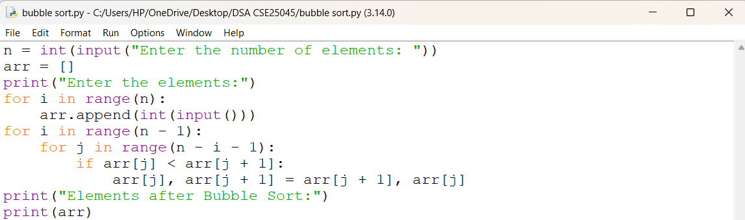
OUTPUT:
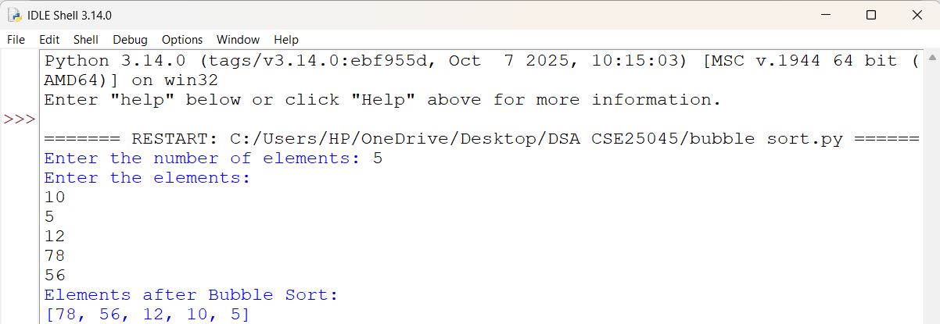
EXPLANATION:
• n = int(input(...)) – Gets the number of elements.
• arr = [] – Creates an empty list to store elements.
• for i in range(n) – Takes n elements as input.
• arr.append(...) – Adds each element to arr.
• for i in range(n - 1) – Performs Bubble Sort passes.
• for j in range(n - i - 1) – Compares adjacent elements.
• if arr[j] < arr[j + 1] – Checks if the current element is smaller.
• arr[j], arr[j + 1] = ... – Swaps the elements to sort in descending order.
• print(arr) – Displays the sorted list.
ERROR TABLE:

S.NO | Error Obtained | Rectification
1. | Sorting Order Error – Using > instead of < in the if condition changes the order to ascending. | Use if arr[j] < arr[j + 1]: for descending order.

3b. AIM: Write a python program to sort the elements using a insertion sort technique. Take the input elements from the user.
PROGRAM:
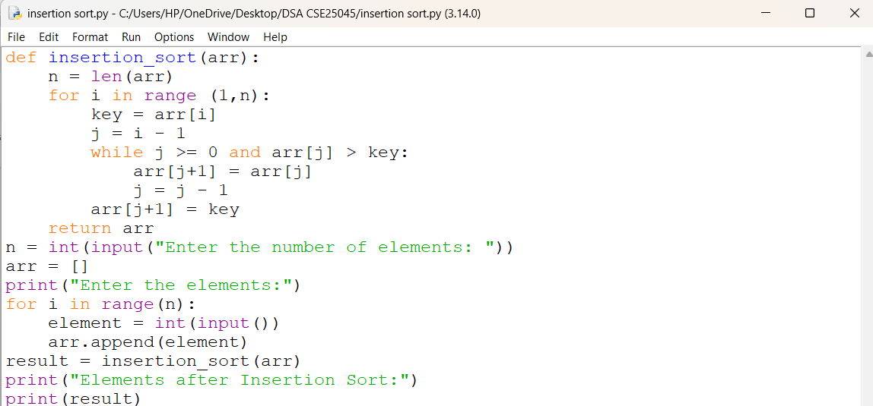
OUTPUT:
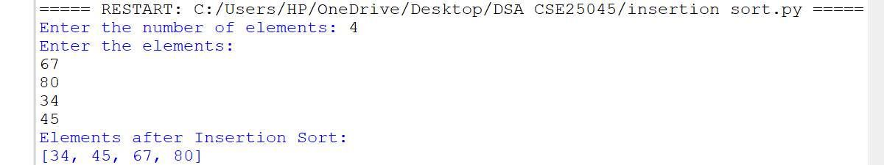
EXPLANATION:
• n = len(arr) – Gets the list size.
• for i in range(1, n) – Selects elements from the second position.
• key = arr[i] – Stores the current element.
• j = i - 1 – Sets the previous index.
• while j >= 0 and arr[j] > key – Compares previous elements with key.
• arr[j + 1] = arr[j] – Shifts larger elements right.
• arr[j + 1] = key – Inserts key in the correct position.
• return arr – Returns the sorted list.
• result = insertion_sort(arr) – Calls the function.
• print(result) – Displays the sorted list.
ERROR TABLE:
S.NO | Error Obtained | Rectification
1. | Insertion Error – Placing key at the wrong index. | Use arr[j + 1] = key after shifting elements.
2. | Function Call Error – Not calling insertion_sort(arr) correctly. | Pass the input list arr to the function.

3c. AIM: Write a python program to sort the elements using a selection sort technique. Take the input elements from the user.
PROGRAM:
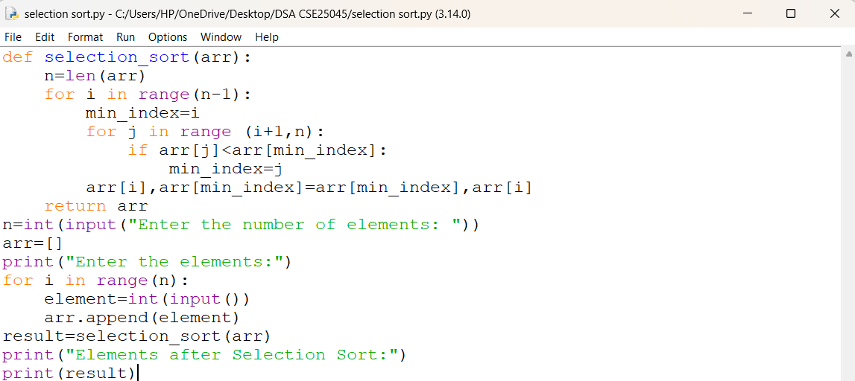
OUTPUT:
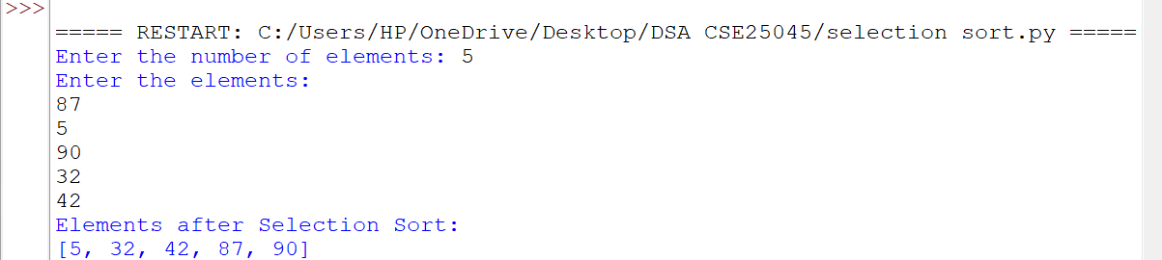
EXPLANATION:
• def selection_sort(arr) – Defines the Selection Sort function.
• n = len(arr) – Gets the number of elements in arr.
• for i in range(n-1) – Performs sorting passes.
• min_index = i – Assumes the first element is the smallest.
• for j in range(i+1,n) – Checks the remaining elements.
• if arr[j] < arr[min_index] – Finds the smallest element.
• arr[i], arr[min_index] = ... – Swaps the smallest element into position.
• return arr – Returns the sorted list.
• result = selection_sort(arr) – Calls the function.
• print(result) – Displays the sorted list in ascending order.
ERROR TABLE:
S.NO | Error Obtained | Rectification
1. | Minimum Index Error – Incorrectly assigning min_index. | Use min_index = i.
2. | Swap Error – Incorrectly swapping the elements. | Use arr[i], arr[min_index] = arr[min_index], arr[i].

3d. AIM: Write a python program to sort the elements using a merge sort technique. Take the input elements from the user.
PROGRAM:
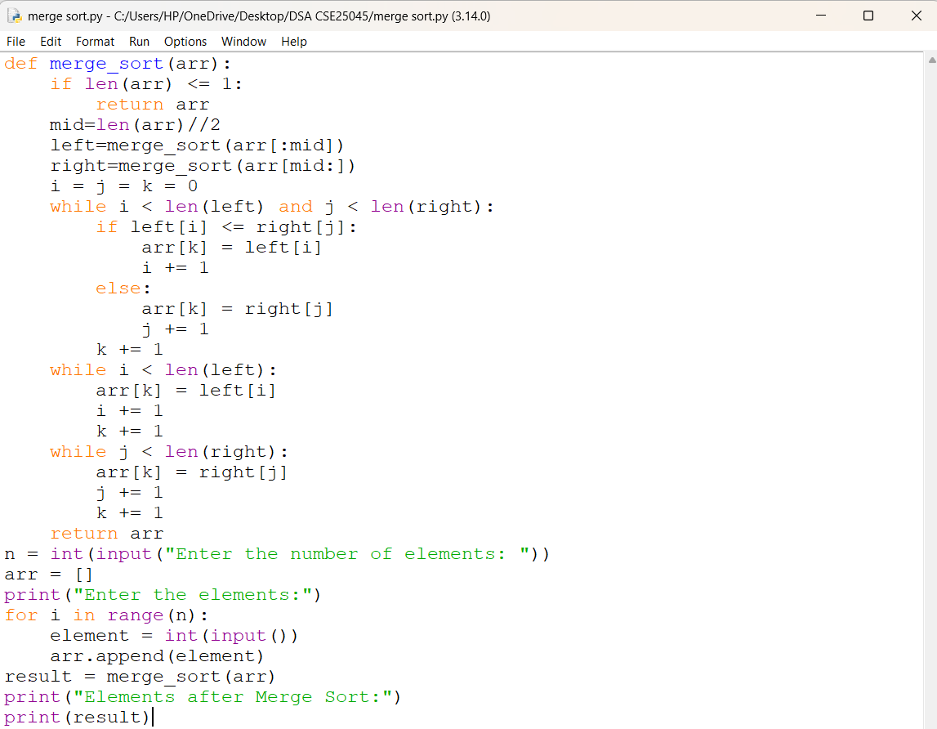
OUTPUT:
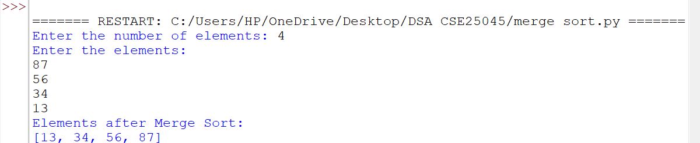
EXPLANATION:
• def merge_sort(arr) – Defines the Merge Sort function.
• if len(arr) <= 1 – Stops when the list has one or no elements.
• mid = len(arr)//2 – Finds the middle of the list.
• left and right – Divide the list into two halves recursively.
• i = j = k = 0 – Initializes the indexes.
• while loops – Compare and merge the elements.
• if left[i] <= right[j] – Selects the smaller element.
• arr[k] – Places the selected element in the list.
• return arr – Returns the sorted list.
• print(result) – Displays the sorted list.
ERROR TABLE:
S.NO | Error Obtained | Rectification
1. | Recursion Error – Incorrectly dividing the list. | Use arr[:mid] and arr[mid:].
2. | Index Error – Incorrectly updating i, j, or k. | Increment the appropriate index after each insertion.

3e. AIM: Write a python program to sort the elements using a quick sort technique. Take the input elements from the user.
PROGRAM:
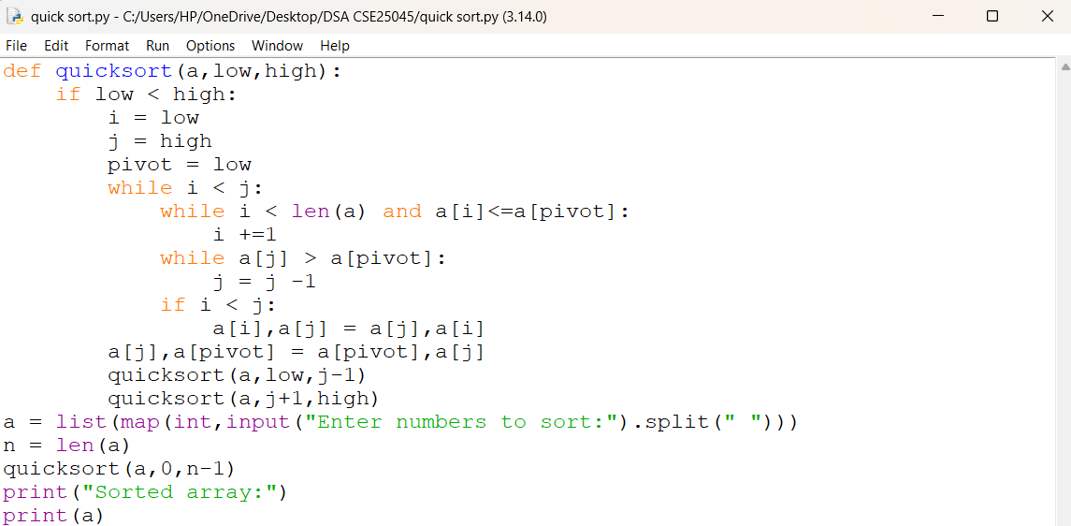
OUTPUT:
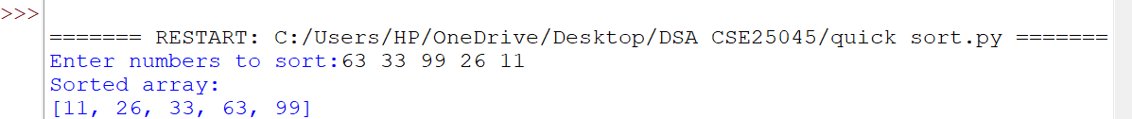
EXPLANATION:
• def quicksort(a, low, high) – Defines the Quick Sort function.
• if low < high – Checks the sorting range.
• i and j – Set left and right positions.
• pivot = low – Selects the first element as pivot.
• while i < j – Performs partitioning.
• Inner while loops – Find elements for swapping.
• a[i], a[j] = ... – Swaps elements.
• a[j], a[pivot] = ... – Places the pivot correctly.
• quicksort() calls – Sort the two partitions.
• input().split() – Takes space-separated numbers.
• print(a) – Displays the sorted array.
ERROR TABLE:
S.NO | Error Obtained | Rectification
1. | Pivot Error – Incorrectly selecting the pivot index. | Use pivot = low.
2. | Swap Error – Incorrect swapping of a[i] and a[j]. | Use a[i], a[j] = a[j], a[i].

WEEK – 4
4. AIM: Write a python program to implement a SLL which could perform the below operations by taking an input from the user.
1) create a LL
2) Insert at beginning
3) Insert at the end
4) Insert at specific position
5) delete by value
6) delete first node
7) delete last node
8) Count no. of nodes
9) display / traverse
10) exit
PROGRAM:
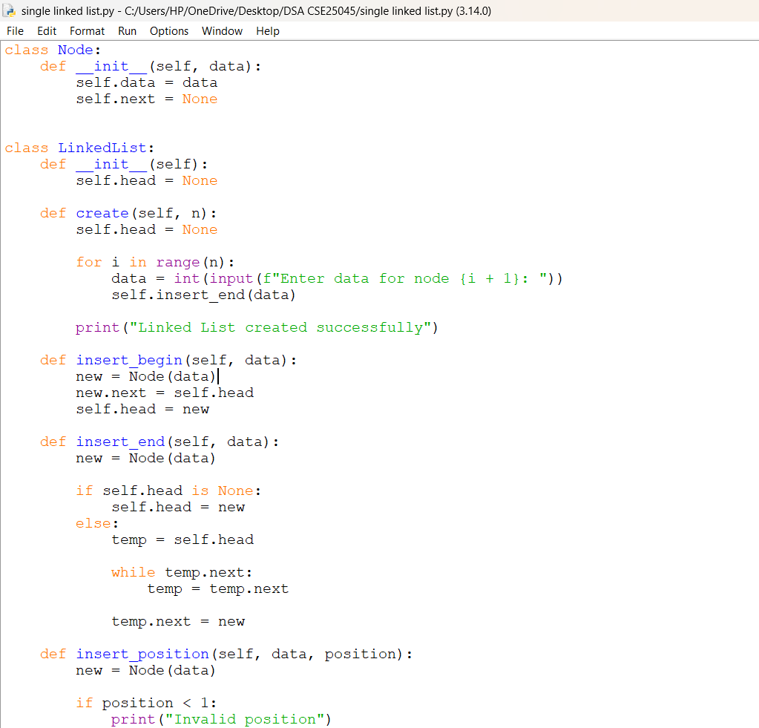
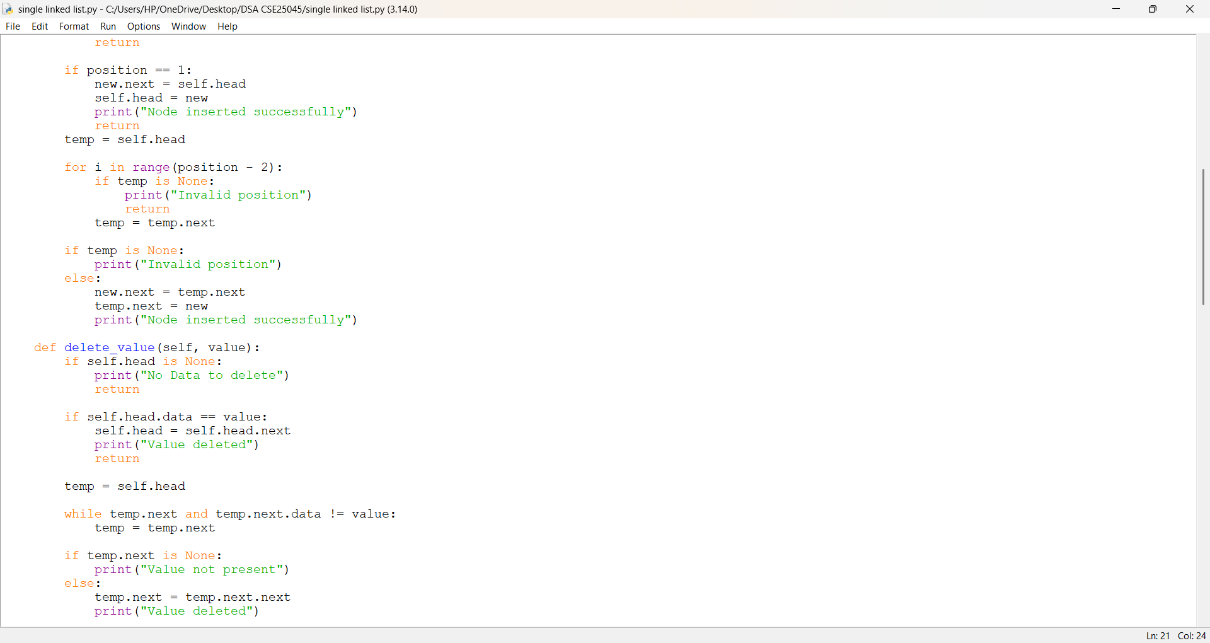
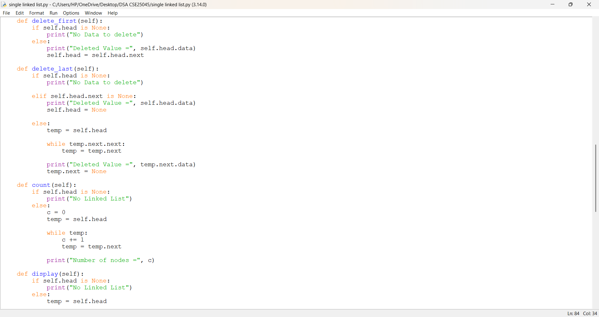
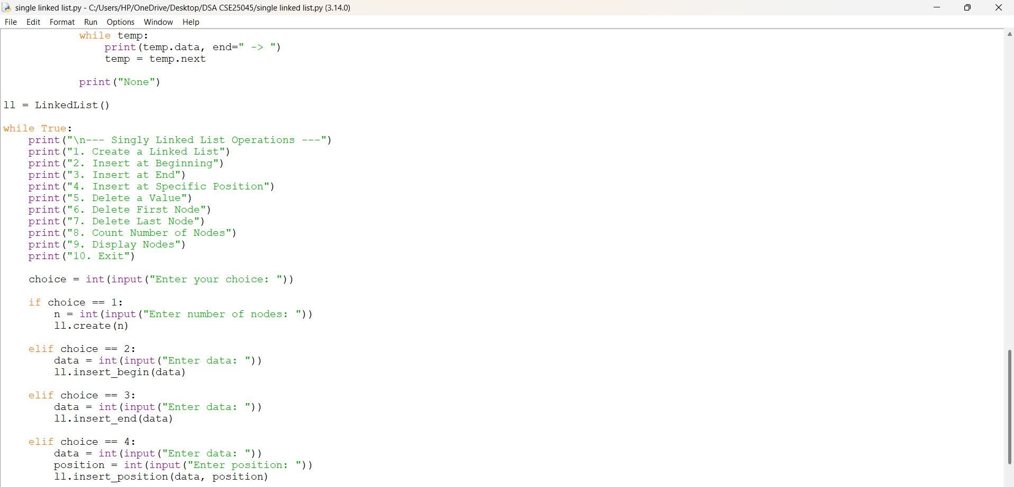
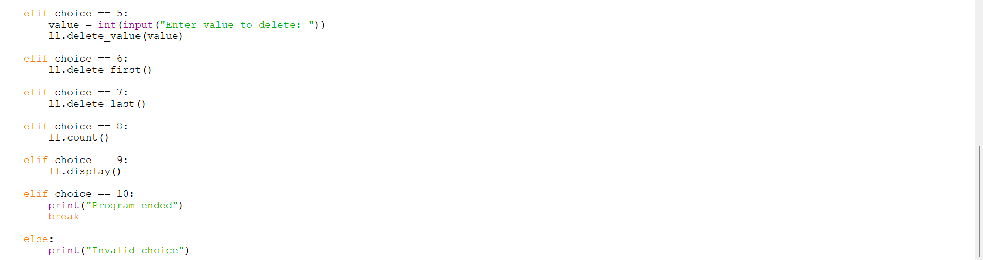
OUTPUT:
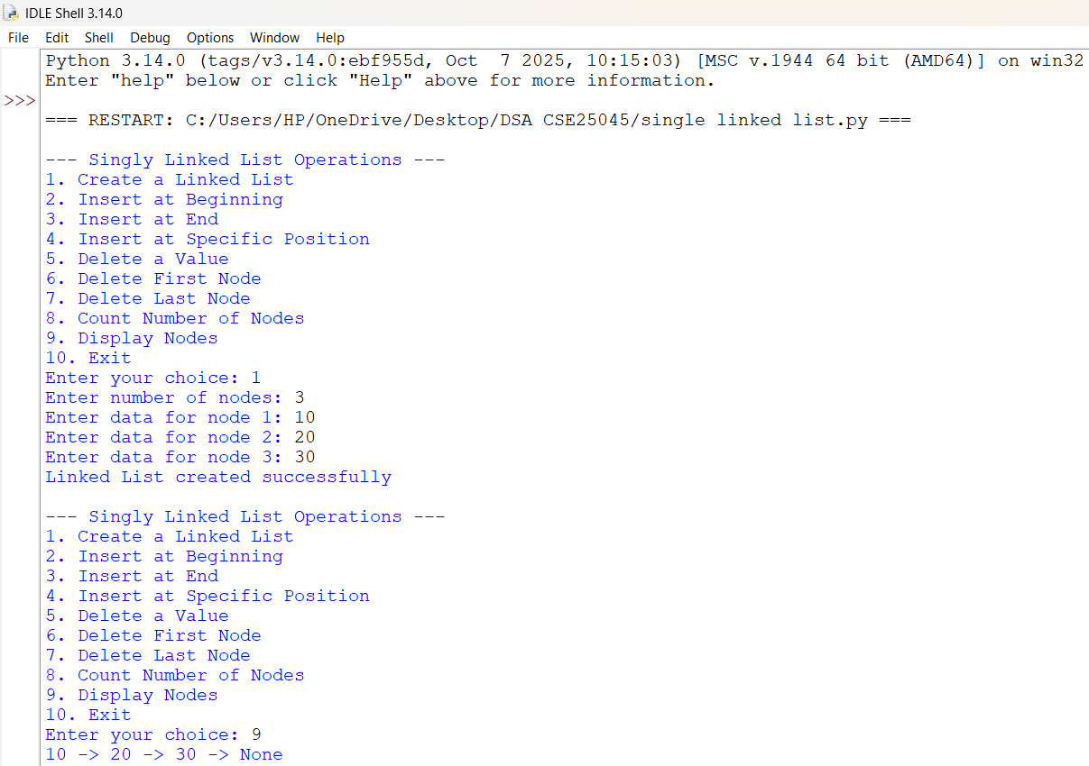
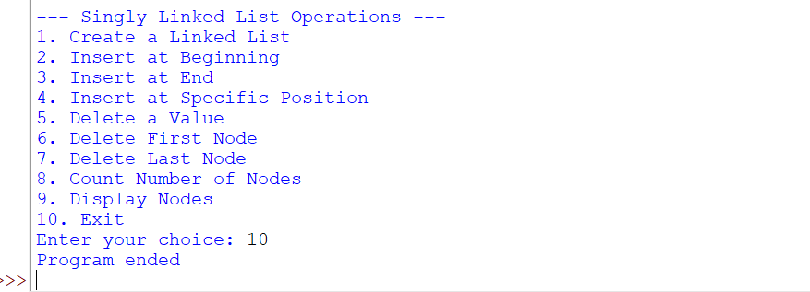

EXPLANATION:
1. class Node
- Defines a node of the Singly Linked List.
- self.data stores the value of the node.
- self.next stores the reference to the next node.
2. class LinkedList
- Defines the Linked List and its operations.
- self.head points to the first node of the list.
3. create()
- Creates n nodes using a for loop.
- Takes data from the user and calls insert_end() to add each node.
4. insert_begin()
- Creates a new node using Node(data).
- new.next = self.head links it to the current first node.
- Updates self.head to make the new node the first node.
5. insert_end()
- Creates a new node.
- Uses while temp.next to traverse to the last node.
- Connects the new node using temp.next = new.
6. insert_position()
- Inserts a node at a specific position.
- Traverses to the required location using a loop.
- Updates the next references to connect the new node correctly.
7. delete_value()
- Searches for a node containing the given value.
- Uses a while loop for traversal.
- Deletes the node by changing the appropriate next reference.
8. delete_first()
- Deletes the first node.
- Updates the head using:
self.head = self.head.next.
9. delete_last()
- Traverses to the second-last node.
- Sets temp.next = None to remove the last node.
- Also handles the special case of a single-node list.
10. count()
- Traverses the linked list using temp.
- Increments counter c for every node.
- Displays the total number of nodes.
11. display()
- Traverses the list from head until None.
- Prints the data of each node in linked list format.
12. Main Program
- ll = LinkedList() creates an object of the LinkedList class.
- while True creates an infinite loop to repeatedly display the menu.
- if-elif statements perform operations based on the user's choice.
- break terminates the loop and ends the program when Exit is selected.
ERROR TABLE:
S.NO | Error Obtained | Rectification
1. | Invalid insertion position. | Added position validation using if position < 1 and if temp is None.
2. | Value to be deleted may not exist. | Checked using if temp.next is None and displayed "Value not present".
3. | Program may terminate unexpectedly during normal operations. | Used proper conditional statements and return statements to control program flow.

